CUBE Sync monitoring and notification system (sop)



Document ID | DigDev_Cube_Sync_Monitoring_and_Notification_System_SOP_v1.0
Product | CUBE
Environment | ALL
Confidentiality Level | Internal / Restricted

Contents
1 DOCUMENT INFORMATION 3
1.1 Validation 3
1.2 Document Distribution 3
1.3 Version Control 3
2 PURPOSE & CONTEXT 4
2.1 About this document 4
2.2 Scope 4
2.3 Roles & Responsibilities 4
2.4 Terminology 4
2.5 Conventions Used 5
3 Monitoring and notification overview 6
3.1 Accessing the Sync Monitor Dashboard 6
3.2 Reviewing the Sync Monitoring Dashboard 7
3.3 Slack Notification Overview 7
3.4 Slack Success Notification Format 8
3.4.1 Responding to Successful Sync Notifications 8
3.5 Slack Failure Notification Format 8
3.5.1 Responding to Failure Notifications 9
3.6 Interpreting Alerts 9
3.6.1 Responding to STALE Status 10
4 Sync workflow and data synchronization behavior 11
4.1 Sync Execution Methods 12
4.2 Cron Job Synchronization Workflow 12
4.3 Incremental Sync Behavior 13
4.4 Decremental Sync Behavior 13
4.5 Webhook Sync Behavior 13
4.6 Archive and Unarchive Workflow 14
4.7 Cache Behavior 15
4.8 API Sync Status 16
4.9 Current Implementation Status 16
5 APPROVAL SIGNATURES 18

DOCUMENT INFORMATION

Validation
Name |  | Role | Date (dd/mm/aa)
Issued by | Oscar Rondon | Technical Writer | 04/05/2026
Verified by | Dhaval Patel | Developer | 04/05/2026
Approved by | Anthony Bures | Digital Development Manager | 04/05/2026

Document Distribution
Normal | Role
Oscar Rondon | Technical Writer
Dhaval Patel | Developer
Anthony Bures | Digital Development Manager

Version Control
Version | Date | Author | Description of changes
1.0 | 04/05/2026 | Oscar Rondon | 1st Version of the Cube Sync Monitoring and Notification System Document

PURPOSE & CONTEXT

About this document
This Standard Operating Procedure defines how to monitor synchronization jobs and respond to related notifications. The procedure explains how to review sync status through the Sync Monitor dashboard, how to interpret Slack notifications for sync success and failure, and how to respond when a sync alert requires attention.
Notifications primarily support the backend team by providing visibility into sync execution results, failures, error details, and possible corrective actions.

Scope
This SOP applies to the sync monitoring and notification process described in the task.
In scope:
- Sync Monitor dashboard review.
- Slack notifications for sync success and failure.
- Optional email alerts using existing templates.
- Failure messaging and error details.
- Alert interpretation.
- Alert response and resolution guidance.
Out of scope:
- Defining the internal implementation of the sync jobs.
- Detailed source code implementation of sync jobs.

Roles & Responsibilities
Role | Responsibilities
Backend Team | Monitor Slack notifications, review the Sync Monitor dashboard, interpret sync success and failure messages, and respond to sync alerts.
Backend Developer | Investigate failed tables, review error details, identify possible causes, and apply corrective actions when required.
Technical Lead | Review recurring or unresolved sync issues and provide guidance when an alert requires escalation.
DevOps | Support Slack channel setup and notification delivery if required.
Technical Writer | Maintain this SOP and update screenshots, alert examples, and response guidance when the process changes.

Terminology
Term Used | Description
Sync | A data synchronization process that updates or aligns data between systems, services, or tables.
Cron Job | A scheduled background process used to run synchronization tasks
Sync Monitor | The dashboard used to review sync status, last sync run, decremental progress, and table-level status.
Incremental Sync | A synchronization path that pulls new or recently updated records.
Decremental Sync | A synchronization path that pulls historical or older records.
Slack Notification | A message sent to a Slack channel to report sync success, sync failure, or sync completion with errors.
Email Alert | An optional email notification that may be configured using existing alert templates.
Backend Team | The team primarily supported by sync monitoring notifications.
Table | A monitored data table shown in the Sync Monitor dashboard or Slack notification.
Last Sync Run | The most recent recorded sync execution time for a table.
Decremental Progress | A dashboard field that displays the sync progress reference shown for monitored tables.
Cursor | A reference value shown under the last sync run that may indicate the sync progress point.
Status | The current condition shown for a monitored table in the Sync Monitor dashboard.
Stale | A status shown in the dashboard indicating that the table has not synced recently, based on the dashboard display.
Success Notification | A notification indicating that a sync completed successfully.
Failure Notification | A notification indicating that a sync completed with errors or failed for one or more tables.
Failed Table | A table listed in a notification as having failed during the sync process.
Error Details | The failure reason shown in the notification.
Corrective Action | An action taken to investigate, resolve, retry, or escalate a sync issue.
Webhook | A trigger-based synchronization mechanism used to update records in near real time when enabled for a table.
Cache | Temporary tracking mechanism used to prevent records from being reprocessed unnecessarily during sync execution.
API Sync Status | API response that exposes synchronization status information for possible dashboard or monitoring use.

Conventions Used
The following structures are used as recommendations.
Info: Supplementary Information

Tip: A recommendation or useful advice

Warning: A warning or important notice

Note: A notice.

Monitoring and notification overview
The sync monitoring and notification system provides visibility into synchronization jobs. The process includes:
- A Sync Monitor dashboard for reviewing sync status by table.
- Slack notifications for sync success and failure.
- Optional email alerts if existing templates are configured and required.
- Failure messages that include error details.
- Alert handling guidance for the backend team.

Accessing the Sync Monitor Dashboard
The Sync Monitor dashboard is available at: https://qa-sync.cube.zters.com/sync/dashboard
The Sync Monitor dashboard shows table-level sync information, including completed sync activity, last sync run, current cursor value, decremental progress, and status. In addition to the dashboard view, sync status information may also be exposed through an API response for monitoring dashboards or future status pages.
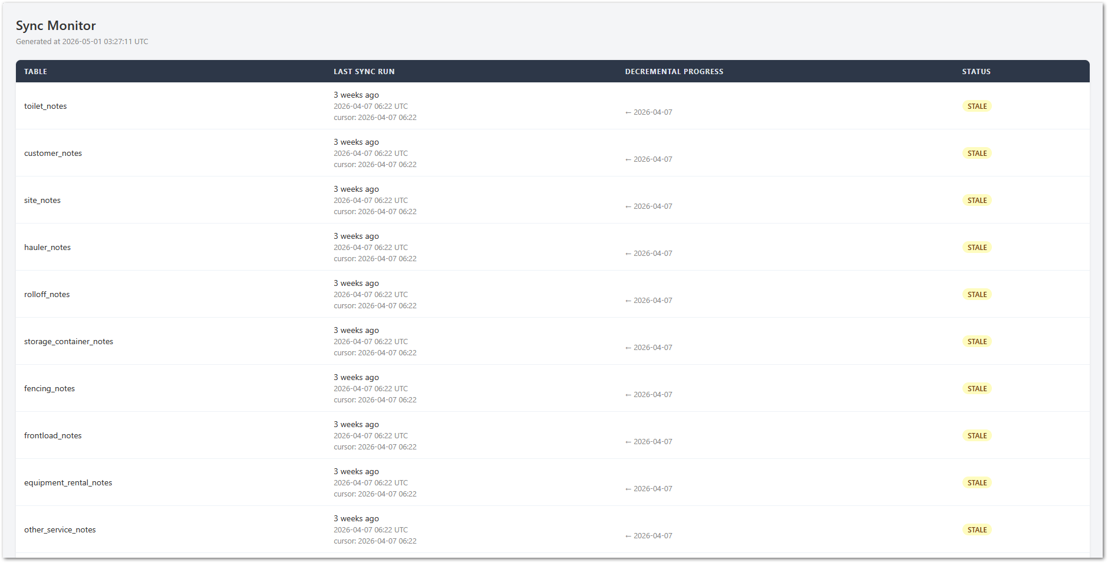
The dashboard displays monitored tables and sync status information. Based on the provided screenshot, the dashboard includes the following columns:
- Table: Shows the monitored table name
- Last Sync Run: Shows when the table last synchronized, including timestamp and cursor details
- Decremental Progress: Shows the progress reference displayed for the sync
- Status: Shows the current table status.

Reviewing the Sync Monitoring Dashboard
The backend team should use the sync monitor dashboard to review table-level sync status. The dashboard screenshot shows the following example tables:
Table
toilet_notes
customer_notes
site_notes
hauler_notes
rolloff_notes
storage_container_notes

The dashboard may show a STALE status when a table has not synchronized recently. When this status appears, the backend team should review the last sync run, cursor value, decremental progress, and related Slack notifications to determine whether the table requires corrective action. When reviewing the dashboard, check:
- The table name.
- The last sync run.
- The timestamp shown under last sync run.
- The cursor value.
- The decremental progress value.
- The current status.

Slack Notification Overview
Slack notifications are used to report sync job results. Based on the provided Slack screenshot, notifications may show:
- Source or sync group.
- Sync type.
- Timestamp.
- Completion status.
- Number of completed tables.
- Number of records processed.
- Duration.
- Failed tables.
- Error details.

Slack Success Notification Format
A successful sync notification may appear as follows:
[backup:other-services | incremental | 2026-04-30 07:04 UTC]
✓ Completed: 1/1 tables | 1000 records | 2s

The success notification includes:
Element | Example | Description
Source / sync group | backup:other-services | Identifies the sync source or group shown in the message.
Sync type | incremental | Identifies the sync type shown in the message.
Timestamp | 2026-04-30 07:04 UTC | Shows when the sync notification was generated.
Completion status | Completed | Indicates that the sync completed successfully.
Table count | 1/1 tables | Shows completed tables compared to expected tables.
Record count | 1000 records | Shows the number of records processed.
Duration | 2s | Shows how long the sync took.

Responding to Successful Sync Notifications
When a successful sync notification is received:
- Review the Slack notification.
- Confirm that the message shows ✓ Completed.
- Review the completed table count.
- Review the record count.
- Review the duration.
- If needed, open the Sync Monitor dashboard.
- Confirm that the related table shows an updated last sync run.
- No additional action is required if the notification appears normal.

Slack Failure Notification Format
A sync notification may also show that the sync completed with errors. Example from the provided screenshot:
[quickbase:users | sync | 2026-04-30 05:19 UTC]
⚠ Completed with errors: 0/1 tables | 0 records | 0s
Failed tables:
• users — No users returned from QuickBase

The failure notification includes:
Element | Example | Description
Source / sync group | quickbase:users | Identifies the sync source or group shown in the message.
Sync type | sync | Identifies the sync type shown in the message.
Timestamp | 2026-04-30 05:19 UTC | Shows when the sync notification was generated.
Completion status | Completed with errors | Indicates that the sync did not complete successfully for all expected tables.
Table count | 0/1 tables | Shows that zero out of one expected table completed successfully.
Record count | 0 records | Shows that no records were processed.
Duration | 0s | Shows the reported sync duration.
Failed table | users | Identify the table that failed.
Error detail | No users returned from QuickBase | Provides the failure reason shown in the alert.

Responding to Failure Notifications
When a sync failure or “completed with errors” notification is received:
- Review the Slack notification.
- Identify the source or sync group.
- Identify the sync type.
- Review the timestamp.
- Review the completed table count.
- Review the record count.
- Identify the failed table.
- Review the error detail.
- Open the Sync Monitor dashboard.
- Search for the affected table.
- Review the last sync run.
- Review the cursor value.
- Review the decremental progress value.
- Review the table status.
- Determine whether corrective action is required.
- Validate the next sync result after corrective action is taken.
- Escalate the issue if it cannot be resolved.
Example:
Failed tables:
• users — No users returned from QuickBase

Interpreting Alerts
Use the following table to interpret sync alerts.
Alert/Status | Where it Appears | Meaning | Response
✓ Completed | Slack | The sync completed successfully. | Review only if the table count, record count, or duration appears unusual.
⚠ Completed with errors | Slack | The sync completed with one or more errors. | Review the failed table and error details.
Failed tables: | Slack | One or more tables failed during the sync. | Identify the failed table and investigate the listed reason.
0 records | Slack | The sync processed zero records. | Confirm whether zero records is expected for that sync.
STALE | Sync Monitor dashboard | The table is shown as stale in the dashboard. | Review last sync run, cursor, decremental progress, and related Slack notifications.

Responding to STALE Status
When a table appears with the STALE status in the Sync Monitor dashboard:
- Open the Sync Monitor dashboard.
- Locate the table marked as STALE.
- Review the last sync run.
- Review the cursor timestamp.
- Review the decremental progress value.
- Check Slack for recent sync alerts related to the table.
- Determine whether the stale status requires corrective action.
- Validate the table after the next successful sync.

Sync workflow and data synchronization behavior
This section describes the high-level synchronization behavior used to move data from QuickBase into MySQL. It explains how the sync process handles scheduled jobs, incremental updates, historical data updates, webhook-triggered updates, cache behavior, and current implementation status.
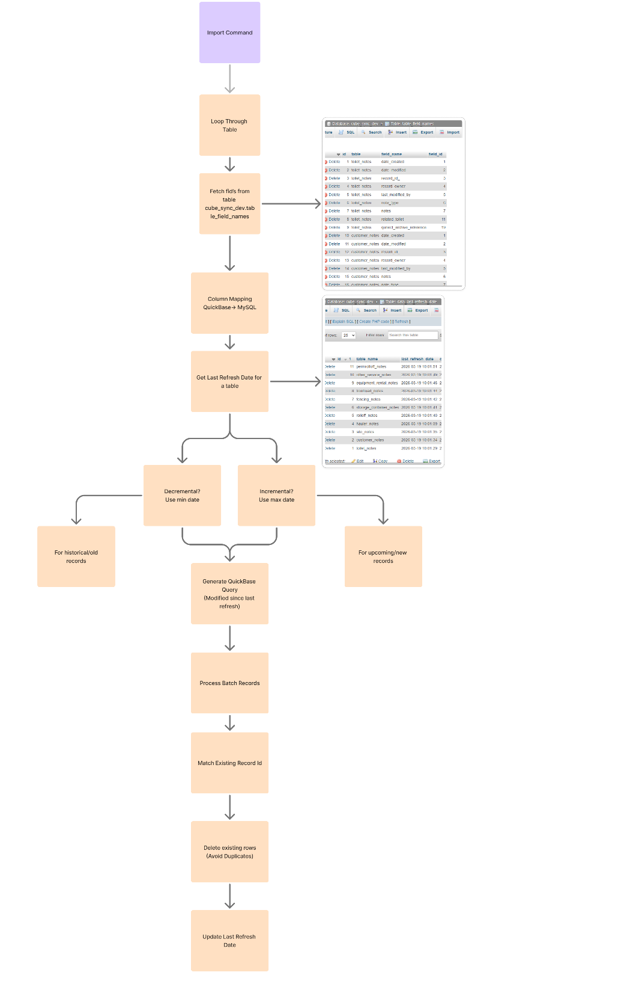
The synchronization process supports monitoring and notification by making sync activity visible through the Sync Monitor dashboard and Slack notifications. The dashboard provides table-level sync status, while Slack notifications provide execution results for completed or failed sync jobs.

Sync Execution Methods
The synchronization process uses different execution methods depending on the type of update being handled.
Sync Method | Description | Frequency / Behavior
Incremental Sync | Pulls new or recently updated records from QuickBase into MySQL. | Runs every 15 minutes without overlapping.
Decremental Sync | Pulls historical or older records that do not currently exist in MySQL. | Runs once per day and currently covers the last 10 days.
Webhook Sync | Supports near real-time updates when a record is updated in QuickBase. | Triggered when enabled for the table.
API Sync Status | Exposes sync status information for dashboard or monitoring use. | Available for current or future monitoring integrations.

The cron-based synchronization process runs in two paths: incremental and decremental. The incremental path supports frequent updates, while the decremental path supports historical record synchronization.
Webhook synchronization is used when selected records require faster update behavior than the scheduled cron job cycle.

Cron Job Synchronization Workflow
The cron job synchronization workflow pulls records from QuickBase into MySQL using predefined table and field mappings. The workflow follows this general process:
- The import command starts the synchronization process.
- The process loops through the predefined tables included in the sync.
- The required fields are fetched from the QuickBase table.
- QuickBase fields are mapped to the corresponding MySQL fields.
- The system checks the last refresh date for the table.
- The sync process determines whether the table should follow the incremental or decremental path.
- Records are processed in batches.
- Existing records are matched by record ID.
- Duplicate rows are avoided during processing.
- The last refresh date is updated after the sync is completed.
The last refresh date is used to determine which records should be considered during the next synchronization cycle. This value helps the sync process identify whether records are new, recently updated, historical, or already processed.

Incremental Sync Behavior
Incremental sync is used to pull new or recently updated records from QuickBase into MySQL. The incremental sync runs every 15 minutes and is intended to process records that were created or updated after the last refresh date. This allows the target MySQL table to remain updated without requiring the full data set to be processed every time. The incremental sync process should:
- Review the last refresh date for the table.
- Identify records created or updated after that value.
- Pull the applicable records from QuickBase.
- Process the records in batches.
- Match records by record ID.
- Insert new records or update existing records as applicable.
- Avoid duplicate rows.
- Update the last refresh date after processing.
The incremental sync should not overlap with another execution of the same process.

Decremental Sync Behavior
Decremental sync is used to pull historical or older records that do not currently exist in MySQL. The decremental sync runs once per day and currently covers records from the last 10 days. This range can be adjusted if the historical synchronization window needs to change. The decremental sync process should:
- Review the configured historical range.
- Identify older records that should exist in MySQL.
- Pull the applicable records from QuickBase.
- Process the records in batches.
- Match records by record ID.
- Insert missing records where applicable.
- Avoid duplicate rows.
- Update the related sync tracking values after processing.
Note: The current decremental range is based on the last 10 days. This value may be changed if the sync strategy requires a different historical window.

Webhook Sync Behavior
Webhook sync is used when selected records need to be updated in near real time. When a webhook is enabled for a table, an update in QuickBase can trigger an update in MySQL without waiting for the next 15-minute incremental sync cycle. The webhook sync process follows this general behavior:
- A record is updated in QuickBase.
- The webhook is triggered for the enabled table.
- The webhook sends the update to MySQL.
- The related MySQL record is inserted or updated.
- The processed record is tracked so the next incremental cron job does not unnecessarily reprocess the same record.
Webhook sync is currently enabled only for selected tables. Additional tables may be enabled in future versions as synchronization coverage expands.

Archive and Unarchive Workflow
The archive command loops through the configured note tables, stores the relevant archive details, and stores the generated files in cloud storage. The archive table keeps the relationship between the QuickBase table name, table name, record ID, and generated file name.
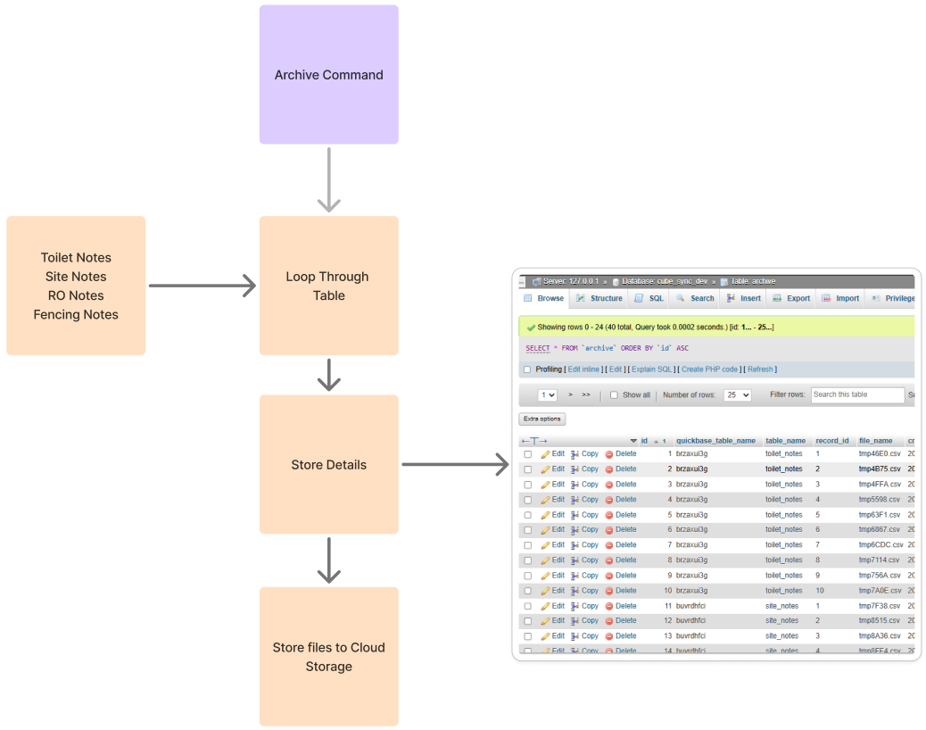
Figma: Archive Command Workflow
The unarchive command reads the archived file, parses the CSV content, and updates the related field content in the target notes table.
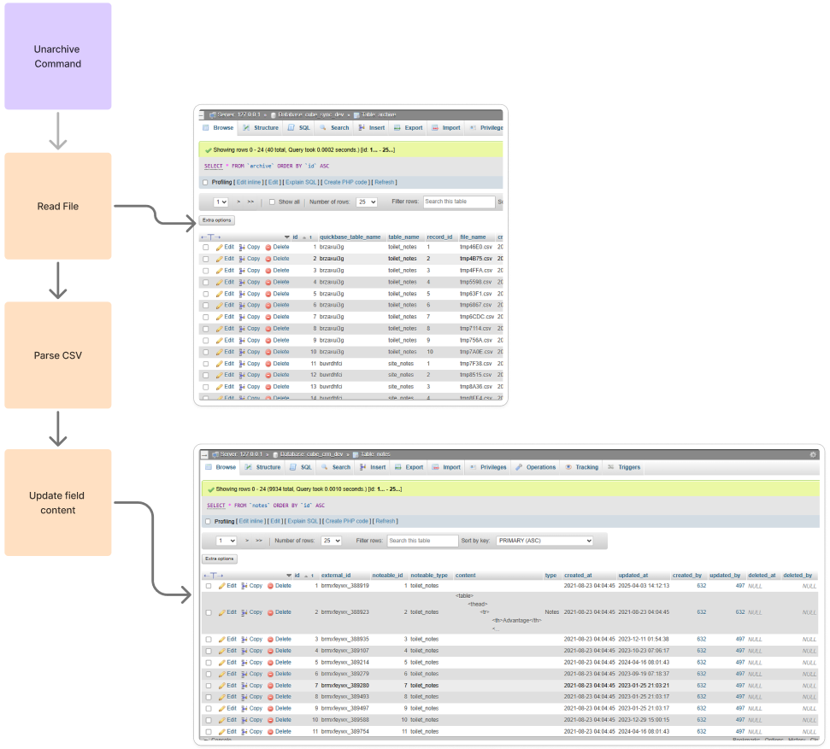
Figma: Unarchive Command Workflow

Cache Behavior
The synchronization process uses cache behavior to prevent records from being processed unnecessarily during the next scheduled sync cycle. When a record is updated through a webhook, the record can be added to the cache. During the next incremental cron job, the sync process checks the cache before processing records. If the record is already present in the cache, the cron job skips that record because it has already been handled recently. The cache behavior follows this general process:
- A record is updated through a webhook.
- The updated record is added to the cache.
- The incremental cron job runs during the next 15-minute cycle.
- The cron job checks whether the record exists in the cache.
- If the record exists in the cache, the cron job skips the record.
- The cache expires or is cleared according to the configured sync behavior.
- After the cache is cleared, the record can be processed again by the appropriate sync method if required.
Warning: If a record already exists in the cache, repeated updates to the same record within the 15-minute window may not be processed immediately through the webhook. The update may be handled by the next cron job after the cache is cleared.

Note: The planned behavior is to keep cache handling for the incremental cron job while allowing webhook updates to support near real-time record updates where enabled.

API Sync Status
Sync status information can also be exposed through an API response. This allows sync status data to be used by monitoring dashboards or future status pages.The API sync status may be used to display information such as:
- Sync job status.
- Completed cron jobs.
- Completion time.
- Current cursor.
- Table-level sync information.
- Sync execution results.
This API-based approach provides flexibility for future monitoring integrations without requiring the Sync Monitor dashboard to be the only visibility point.

Current Implementation Status
The current synchronization implementation is limited to the tables and environments currently enabled for testing and monitoring.
Area | Current Status
Development / QA / Web UAT cron jobs | Cron jobs are currently disabled or limited to avoid unnecessary QuickBase API usage
Production cron jobs | Cron jobs are expected to be enabled when the process is moved to production
Current data source | QuickBase
Current target database | MySQL
Webhook testing | Webhook testing is currently performed with the other_service table
Current webhook coverage | Webhook is currently enabled for the other_service table
Current sync coverage | Current work includes notes tables and the other_service table
Future sync coverage | Additional tables may be added in later document versions.

The current document version should be treated as the initial version of the sync monitoring and notification SOP. As additional tables are enabled for synchronization or webhook behavior, the document should be updated with the new table coverage and related behavior.

Sync Table Coverage
The following table should be maintained as new tables are added to the synchronization process.
Table | Sync Method | Webhook Enabled | Notes
Notes tables | Cron-based sync | TBD | Included in the current sync monitoring scope
Other services table | Webhook testing | Yes | Used for webhook testing and validation
Additional QuickBase tables | TBD | TBD | To be added in future document versions as synchronization coverage expands

Note: This table should be updated whenever a new QuickBase table is added to the synchronization process or when webhook behavior is enabled for an additional table.

Sync Validation
Sync validation confirms that records are being synchronized as expected between QuickBase and MySQL. Validation may include:
- Updating a test record in QuickBase.
- Confirming whether the webhook is enabled for the related table.
- Reviewing whether the record is inserted or updated in MySQL.
- Checking whether the record appears in the cache.
- Confirming whether the next incremental cron job skips cached records as expected.
- Reviewing Slack notifications for sync success or failure.
- Reviewing the Sync Monitor dashboard for updated status, last sync run, and cursor values.
- Confirming that the record count and completed table count are expected.

APPROVAL SIGNATURES
Digital signature blocks below are formatted for DocuSign / Adobe Sign.
Name | Role | Digital Signature Block | Date (dd/mm/aa)
Oscar Rondon | Technical Writer |  | 04/05/2026
Dhaval Patel | Developer |  | 04/05/2026
Anthony Bures | Digital Development Manager |  | 04/05/2026

--- END OF THE DOCUMENT ---

